**In-class Examples**

***Example 1:***

Students flip coins 10 times and record outcomes.

***Example 2:***

Two students administering the same survey to different samples of the same population could get different results. If the results are too different from one another, the results are in question.

***Example 3:***

(a) S = {lives on campus, lives off campus}.

(b) S = {All numbers between _______ and _______ years}. (Choices of upper and lower limits will vary.)

(c) S = {all amounts greater than or equal to 0}, or S = {0, 0.01, 0.02, 0.03, . . .}.

(d) S = {A, B, C, D, F} (students might also include “+” and “–”).

***Example 4-5:***

|  |  |  |  |  |  |  |
| --- | --- | --- | --- | --- | --- | --- |
| **Sample Space** | 1 | 2 | 3 | 4 | 5 | 6 |
| **Probability** | 1/6 | 1/6 | 1/6 | 1/6 | 1/6 | 1/6 |
| **Sample Space** | 1 | -2 | 3 | -4 | 5 | -6 |
| **Probability** | 1/6 | 1/6 | 1/6 | 1/6 | 1/6 | 1/6 |
| **Sample Space** | X | | 2X | | 3X | |
| **Probability** | 1/3 | | 1/3 | | 1/3 | |

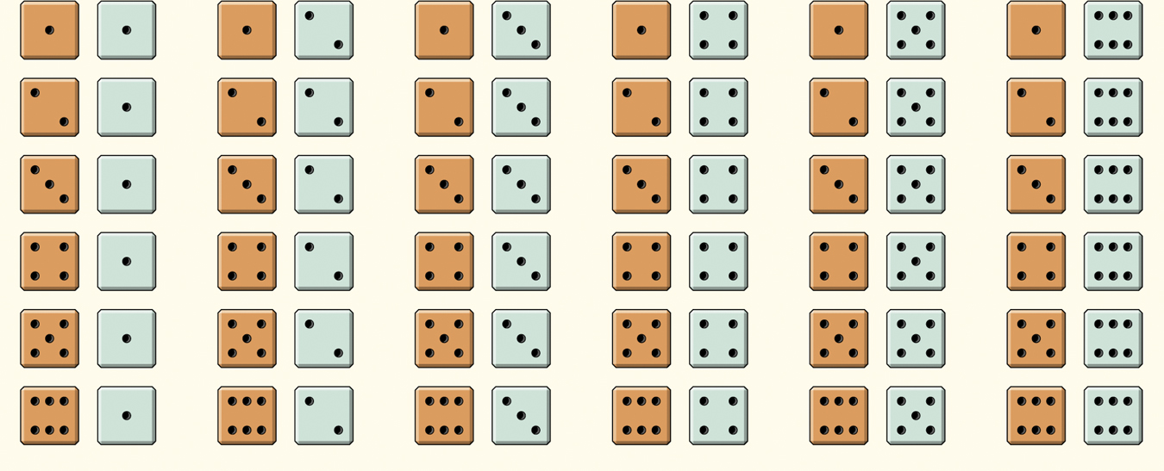

***Example 6:***

|  |  |  |  |
| --- | --- | --- | --- |
| 4 | 0 |  | 1. This event is certain. It will occur on every trial. 2. This event will occur slightly less often than not. 3. This event will occur as often as not. 4. This event is impossible. It will never occur. 5. This event is unlikely but will occur once in a while in a long sequence of trials. |
| 5 | 0.01 |  |
| 2 | 0.45 |  |
| 3 | 0.50 |  |
|  | 0.55 |  |
|  | 0.99 |  |
| 1 | 1 |  |

***Example 7:***

(a) The given probabilities have sum 0.90, so *P*(other language) = 0.10.

(b) *P*(not English) = 1 − 0.08 = 0.92. (Or, add the other three probabilities.)

(c) *P* (neither English nor French) = 0.02 + 0.10 = 0.12. (Or, subtract 0.08 + 0.80 from 1.)

***Example 8:***

1. Each event specifically rules out the others. You can’t have none, one, AND two children nor can you have none AND one.
2. The person chosen has no children, one child, or two children. The probability that the person chosen has no children, one child, or two children.
3. P(D)=0.10

***Example 9:***

1. It is a legitimate probability model because…

* Each probability is between 0 and 1
* 0.57 + 0.17 + 0.14 + 0.12 = 1

1. P(not traditional college age) = *P*(not 18 to 23 years) = 1 – *P*(18 to 23 years) = 1 – 0.57 = 0.43

***Example 10:***

*P*(X ≤ 0.5 or X > 0.8) = *P*(X ≤ 0.5) + *P*(X > 0.8) = 0.5 + 0.2 = 0.7

***Example 11:***

S={TTT, HTT, THT, TTH, THH, HTH, HHT, HHH}

|  |  |  |  |  |
| --- | --- | --- | --- | --- |
| X=number of heads | 0 | 1 | 2 | 3 |
| Outcomes | TTT | HTT, THT, TTH | THH, HTH, HHT | HHH |

|  |  |  |  |  |
| --- | --- | --- | --- | --- |
| X=number of heads | 0 | 1 | 2 | 3 |
| Probability | 1/8 | 3/8 | 3/8 | 1/8 |

***Example 12:***

|  |  |  |  |  |  |  |  |  |  |  |  |
| --- | --- | --- | --- | --- | --- | --- | --- | --- | --- | --- | --- |
| **X=sum** | 2 | 3 | 4 | 5 | 6 | 7 | 8 | 9 | 10 | 11 | 12 |
| **Probability** | 1/36 | 2/36 | 3/36 | 4/36 | 5/36 | 6/36 | 5/36 | 4/36 | 3/36 | 2/36 | 1/36 |

***Example 13:***

|  |  |  |  |  |  |
| --- | --- | --- | --- | --- | --- |
| X=points | 4 | 3 | 2 | 1 | 0 |
| Probability | 0.17 | 0.37 | 0.26 | 0.12 | 0.08 |

1. Discrete because it has a finite sample space
2. “At least a C” is the event {X ≥ 2} OR {X > 1}  
   P(X ≥ 2) = P(X = 4) + P(X = 3) + P(X = 2) = 0.17+0.37+0.26 = 0.80
3. The event X ≤ 1 is “a grade of D or F” or “at most a D”  
   P(X ≤ 1) = P(X = 1) + P(X = 0) = 0.12 + 0.08 = 0.20   
   P( X < 1) = P(X = 0) = 0.08